REACT NATIVE

1. if we need to change the dimension of button : we can not do that with the style for that we can use :TouchableOpacity or

TouchableHighlight

<*TouchableOpacity* style={style.button}

        activeOpacity={0.96}

        onPress={onsubmit}

        >

          <*Text* style={style.buttonText}>Submit</*Text*>

        </*TouchableOpacity*>

2. to make a password field :

we can use securetyEntery={true};

<*TextInput* secureTextEntry={true} placeholder='Enter password'></*TextInput*>

3. box shadow

shadowColor:’red’,

eleviation:5,

shadowOpacity:0.6

4. Radio button

import {React, useState} from 'react';

import {View, Text, TouchableOpacity} from 'react-native';

import {StyleSheet} from 'react-native';

*const* App = () *=>* {

*const* [acitve1, setActive1] = useState(false);

*const* [acitve2, setActive2] = useState(false);

  return (

    <>

      <*View* style={style.main}>

        <*View* style={style.touchable}>

          <*TouchableOpacity*

            onPress={() *=>* {

              setActive1(!acitve1);

            }}>

            <*Text* style={acitve1 ? style.radio : style.radioActive}></*Text*>

          </*TouchableOpacity*>

          <*Text*>Radio1</*Text*>

        </*View*>

        <*View* style={style.touchable}>

          <*TouchableOpacity*

            onPress={() *=>* {

              setActive2(!acitve2);

            }}>

            <*Text* style={acitve2 ? style.radio : style.radioActive}></*Text*>

          </*TouchableOpacity*>

          <*Text*>Radio2</*Text*>

        </*View*>

      </*View*>

    </>

  );

};

*const* style = StyleSheet.create({

  main: {

    flex: 1,

    borderWidth: 3,

    borderColor: 'red',

    margin: 10,

    padding: 10,

  },

  radio: {

    width: 25,

    height: 25,

    borderWidth: 1,

    borderColor: 'green',

    marginRight: 5,

    borderRadius: 12.5,

  },

  radioActive: {

    width: 25,

    height: 25,

    borderWidth: 1,

    borderColor: 'green',

    marginRight: 5,

    borderRadius: 12.5,

    backgroundColor: 'green',

  },

  touchable: {

    flexDirection: 'row',

    marginVertical: 5,

  },

});

export default App;

5 . to make a scroll kind of things just import scrollView

6. SafeAreaView : it is only work for ios

to give safeAreaView for android we have to give it manually by importing statusbar

and :

paddingTop:Platform.OS==="android"?StatusBar.currentHeight:0

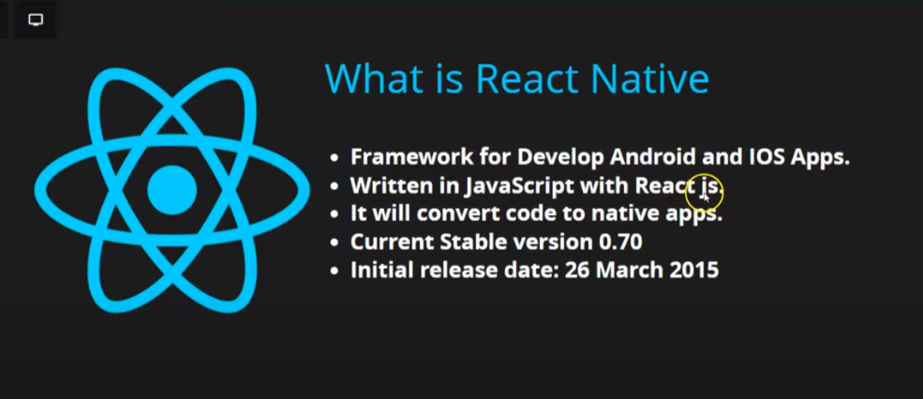

setUp-

Note : insall them in command prompt by running it as adminstrator

# 1 .install Chocolatey

<https://chocolatey.org/install>

to check installiation : chocolatey -v

step 2 : install jdk file from reactive native web page

to check installiation :

java –version ( in new tab of command prompt )

step 3 :download android studio

<https://reactnative.dev/docs/environment-setup?guide=native>

to give inline font-size :

style={{fontSize:15}}

react-file information :

1. metor.config.js :

it helps in fast reloading of react-native application

1 .

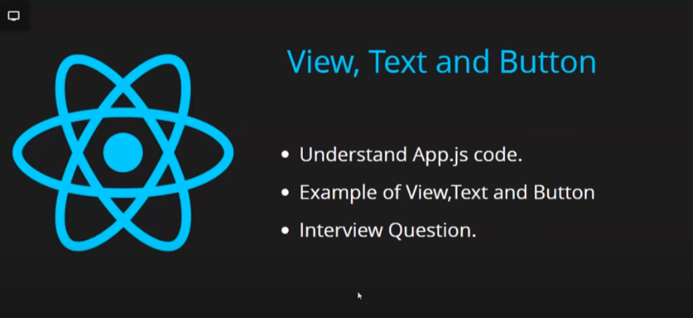

i) view : is like div (wraper)

ii ) Text to write text

iii)Button

<*Button* title='press Here'></*Button*>

iv) TextInput : for input field

interview Qestion :

Q1. diffrence between html tag and react-native tag ?

html tag starts with small letter but react-native tag starts with Capital letter.

2.

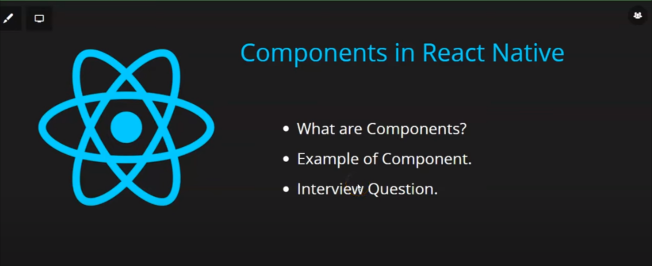

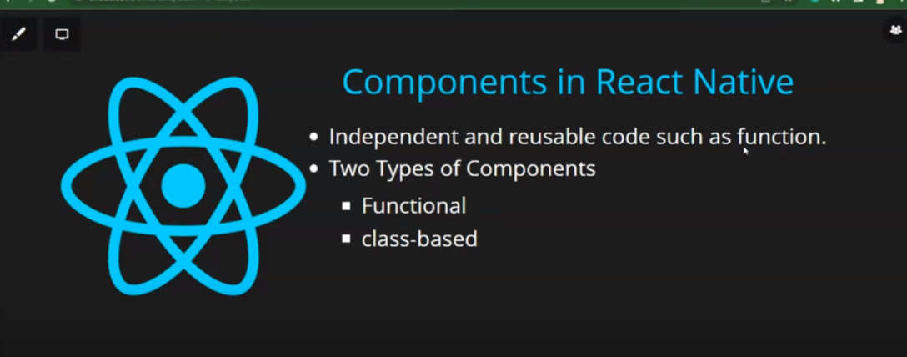

3.

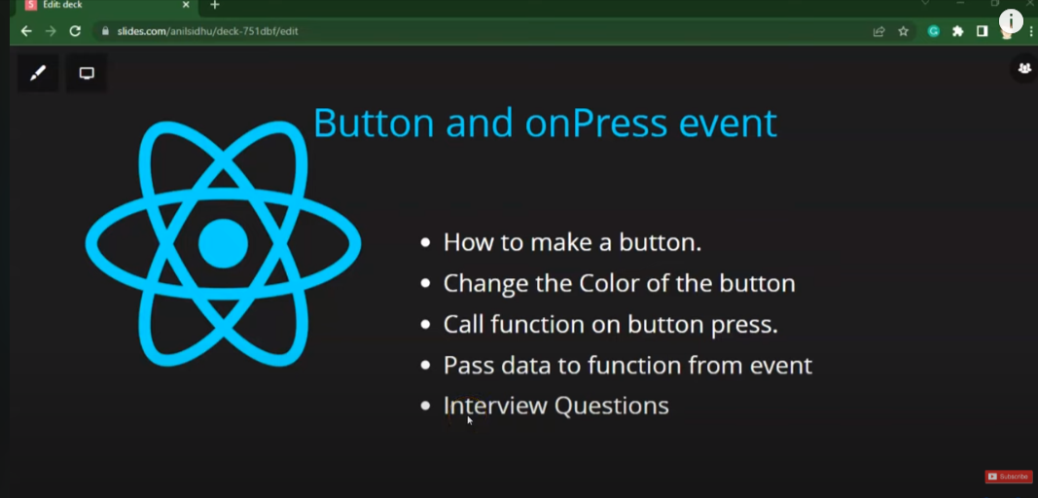

i)button color setting : <*Button* title="press Me" color="red"></*Button*>

4.

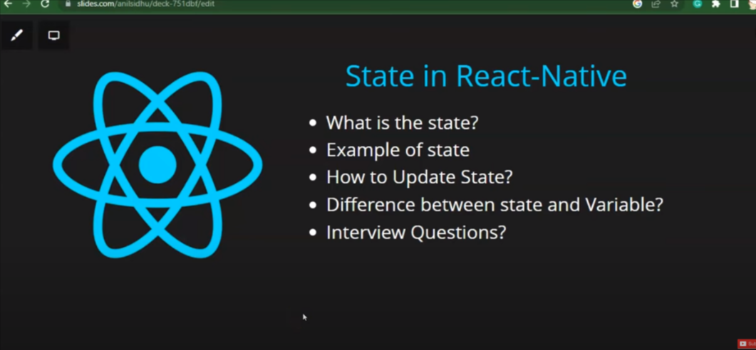

5.

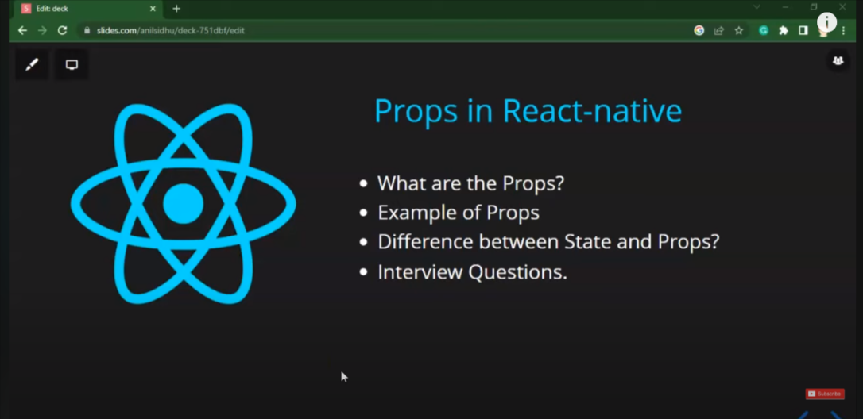

6. styling

1. inlinestyle :

style={{fontSize: 20, padding:5, textAlign: 'justify'}}

2. internal style

-> import {StyleSheet} from ‘react-navite’

import {StyleSheet} from 'react-native';

-->

*const* text = StyleSheet.create({

  textBox: {

    color: 'green',

    paddingHorizontal: 10,

    marginVertical: 10,

    fontSize:17

  },

});

-->

style={text.textBox}

iii) external style

make a file with .js ans wirter the internal style there and then exports

7.

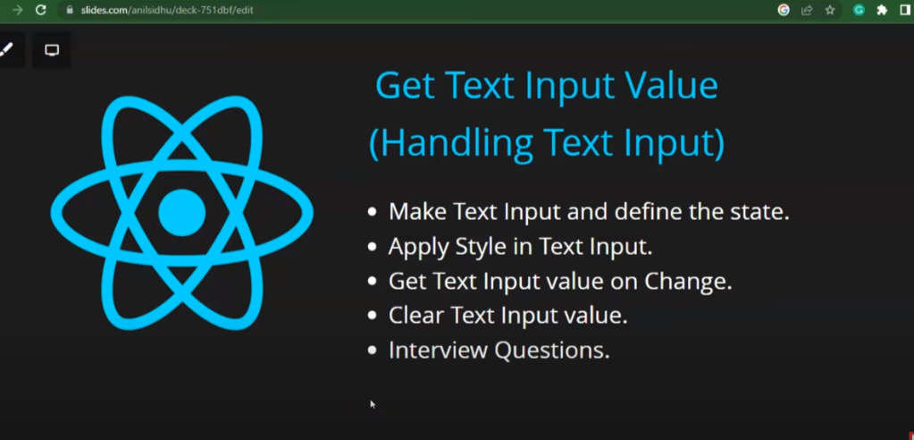

import {React, useState} from 'react';

import {View, Text, TextInput, TouchableOpacity} from 'react-native';

import {StyleSheet} from 'react-native';

*const* App = () *=>* {

*const* [name, setName] = useState(null);

*function* changefun(*e*) {

    setName(*e*);

  }

*function* onsubmit() {

    setName(null);

  }

  return (

    <*View*>

      <*Text* style={style.textBox}>Handel Text input</*Text*>

      <*TextInput*

        style={{

          borderWidth: 2,

          marginTop: 20,

          marginHorizontal: 15,

          fontWeight: 'bold',

          fontSize: 18,

          borderRadius: 5,

          paddingLeft: 10,

          borderColor: 'green',

          color: 'red',

        }}

        onChangeText={changefun}

        placeholder="Enter Your Name"

        value={name}></*TextInput*>

      <*View* style={style.buttonParent}>

        <*TouchableOpacity*

          style={style.button}

          activeOpacity={0.96}

          onPress={onsubmit}>

          <*Text* style={style.buttonText}>Submit</*Text*>

        </*TouchableOpacity*>

      </*View*>

      <*Text* style={{margin: 20, fontSize: 20}}>Name:{name}</*Text*>

    </*View*>

  );

};

*const* style = StyleSheet.create({

  textBox: {

    fontSize: 30,

    marginLeft: 10,

    marginTop: 10,

  },

  buttonParent: {

    alignSelf: 'center',

    alignItems: 'center',

    width: 100,

    borderWidth: 2,

    marginTop: 20,

    backgroundColor: 'green',

    borderRadius: 5,

  },

  button: {

    borderColor: 'grey',

    paddingVertical: 5,

    color: 'red',

  },

  buttonText: {

    color: 'white',

    fontSize: 15,

  },

});

8.

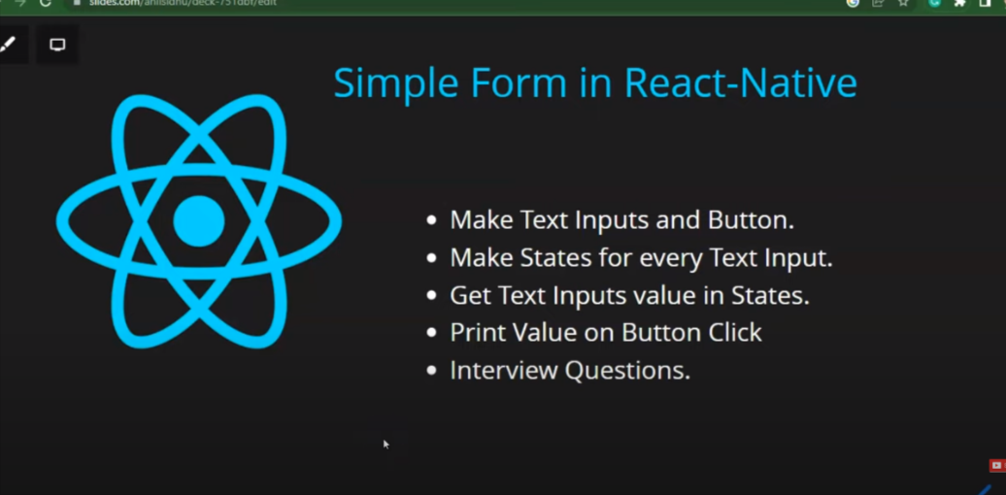

9.

List with Flat List

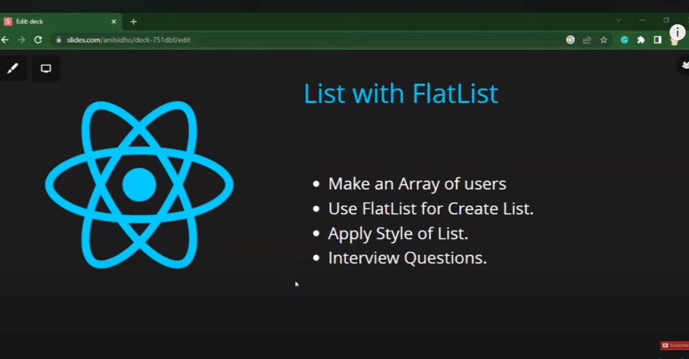

import {React, useState} from 'react';

import {View, Text, TextInput, TouchableOpacity, FlatList} from 'react-native';

import {StyleSheet} from 'react-native';

*const* App = () *=>* {

*const* User = [

    {

      id: 1,

      Name: 'Ajaj Alam',

    },

    {

      id: 2,

      Name: 'Anupam',

    },

    {

      id: 3,

      Name: 'Rudra',

    },

    {

      id: 4,

      Name: 'AmanJeet',

    },

    {

      id: 5,

      Name: 'Anurag',

    },

  ];

  return (

    <>

      <*View*>

        <*FlatList*

          data={User}

          renderItem={({*item*}) *=>* <*Text*>{*item*.Name}</*Text*>}

          keyExtractor={*item* *=>* *item*.id}

        />

      </*View*>

    </>

  );

};

*const* style = StyleSheet.create({});

export default App;

10.

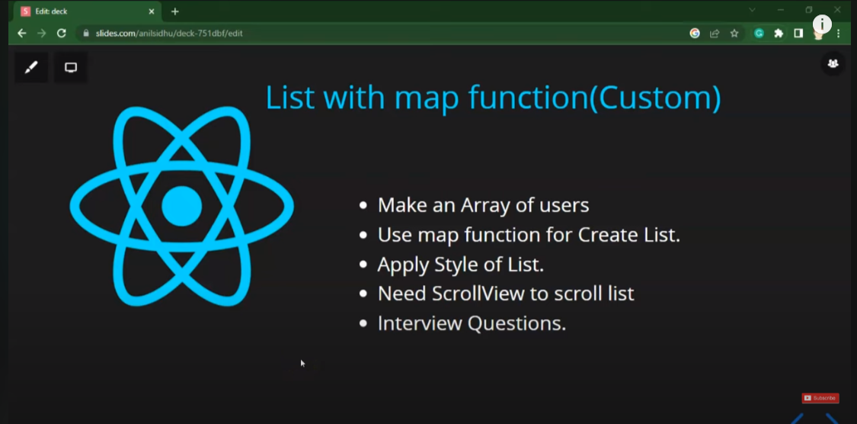

import {React, useState} from 'react';

import {View, Text, TextInput, TouchableOpacity, FlatList} from 'react-native';

import {StyleSheet} from 'react-native';

*const* App = () *=>* {

*const* User = [

    {

      id: 1,

      Name: 'Ajaj Alam',

    },

    {

      id: 2,

      Name: 'Anupam',

    },

    {

      id: 3,

      Name: 'Rudra',

    },

    {

      id: 4,

      Name: 'AmanJeet',

    },

    {

      id: 5,

      Name: 'Anurag',

    },

  ];

  return (

    <>

      <*View*>

        {User.map(*item* *=>* (

          <*Text* key={*item*.id}>{*item*.Name}</*Text*>

        ))}

      </*View*>

    </>

  );

};

*const* style = StyleSheet.create({});

export default App;

Demerit of list with map =>

i)performace issue with the larger data

like : when we scroll

11.

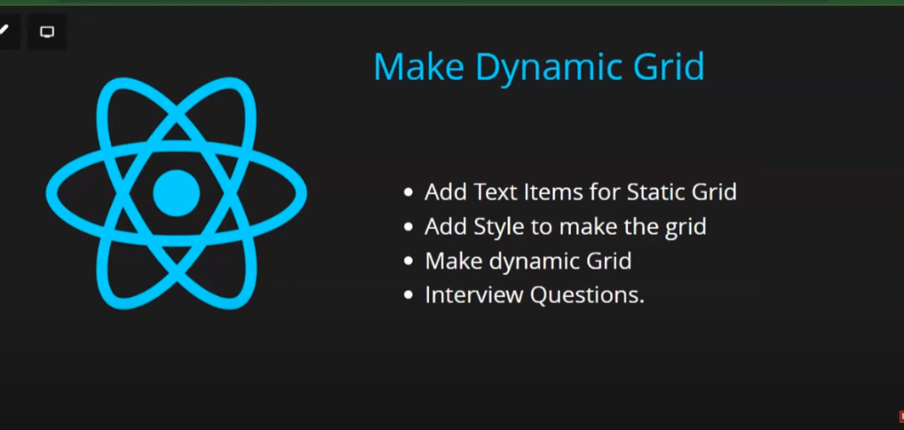

import {React, useState} from 'react';

import {View, Text, TextInput, TouchableOpacity, FlatList} from 'react-native';

import {StyleSheet} from 'react-native';

*const* App = () *=>* {

*const* User = [

    {

      id: 1,

      Name: 'Ajaj Alam',

    },

    {

      id: 2,

      Name: 'Anupam',

    },

    {

      id: 3,

      Name: 'Rudra',

    },

    {

      id: 4,

      Name: 'AmanJeet',

    },

    {

      id: 5,

      Name: 'Anurag',

    },

    {

      id: 6,

      Name: 'Anurag',

    },

    {

      id: 6,

      Name: 'Anurag',

    },

    {

      id: 6,

      Name: 'Anurag',

    },

    {

      id: 6,

      Name: 'Anurag',

    },

    {

      id: 6,

      Name: 'Anurag',

    },

    {

      id: 6,

      Name: 'Anurag',

    },

    {

      id: 6,

      Name: 'Anurag',

    },

  ];

  return (

    <>

      <*View* style={style.container}>

        {User.map(*item* *=>* (

          <*Text* key={*item*.id} style={style.item}>

            {*item*.Name}

          </*Text*>

        ))}

      </*View*>

    </>

  );

};

*const* style = StyleSheet.create({

  container: {

    flex: 1,

    flexDirection: 'row',

    flexWrap: 'wrap',

    borderWidth: 2,

    borderColor: 'red',

    marginHorizontal: 10,

    justifyContent:'center'

  },

  item: {

    width: 120,

    height: 120,

    borderWidth: 2,

    borderColor: 'green',

    margin: 2,

    textAlignVertical: 'center',

    textAlign: 'center',

  },

});

export default App;

12 .

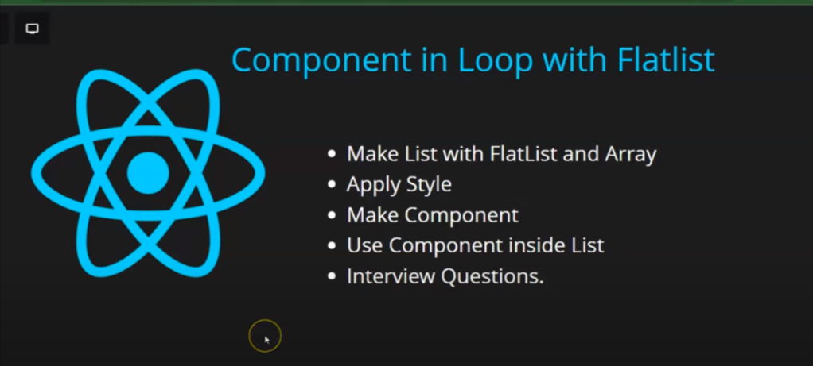

import {React, useState} from 'react';

import {View, Text, TextInput, TouchableOpacity, FlatList} from 'react-native';

import {StyleSheet} from 'react-native';

*const* App = () *=>* {

*const* UserData = [

    {

      id: 1,

      Name: 'Ajaj Alam',

    },

    {

      id: 2,

      Name: 'Anupam',

    },

    {

      id: 3,

      Name: 'Rudra',

    },

    {

      id: 4,

      Name: 'AmanJeet',

    },

    {

      id: 5,

      Name: 'Anurag',

    },

  ];

  return (

    <>

      <*View*>

        <*FlatList*

          data={UserData}

          renderItem={({*item*}) *=>* <*User* data={*item*} />}

        />

      </*View*>

    </>

  );

};

*function* User(*porps*) {

*const* item = *porps*.data;

  return (

    <>

      <*View*>

        <*Text*>

          id :{item.id} id Name:{item.Name}{' '}

        </*Text*>

      </*View*>

    </>

  );

}

export default App;

13 . class component

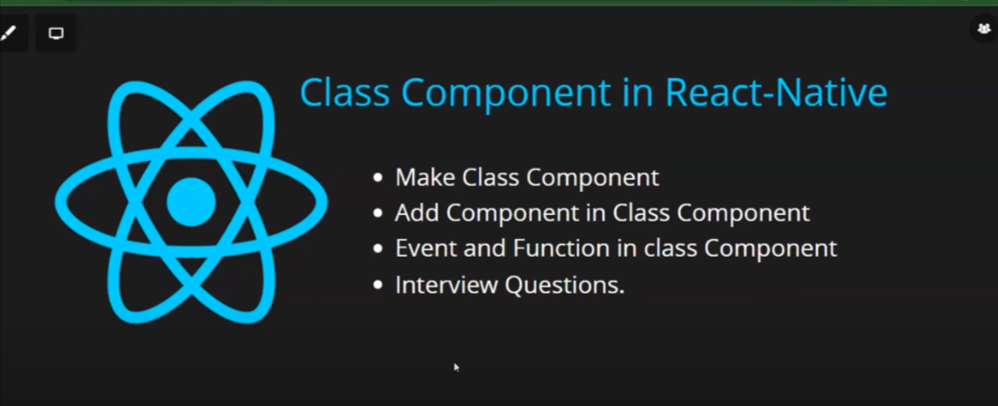



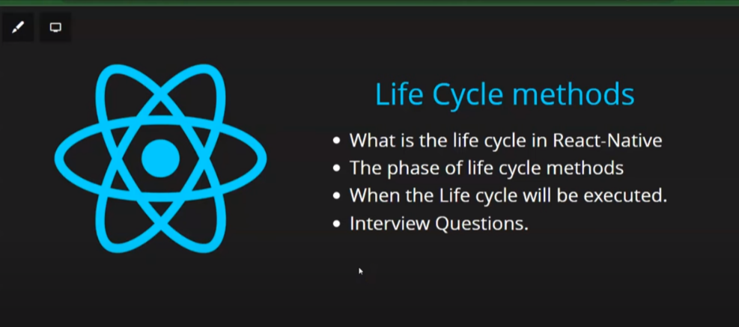

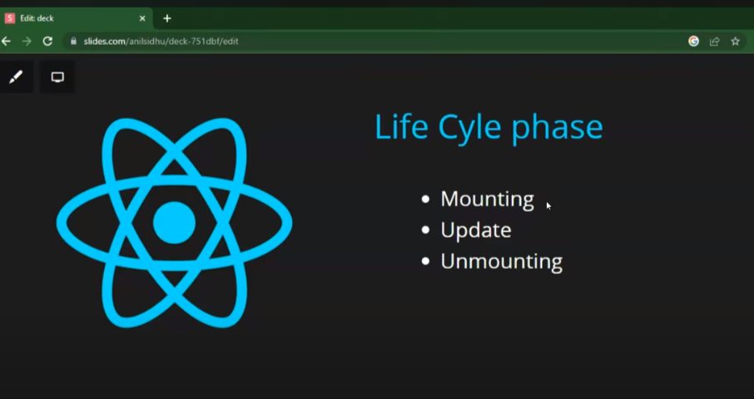

14 .

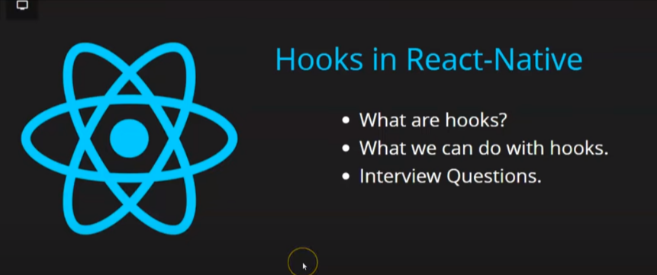

i)-



ii)

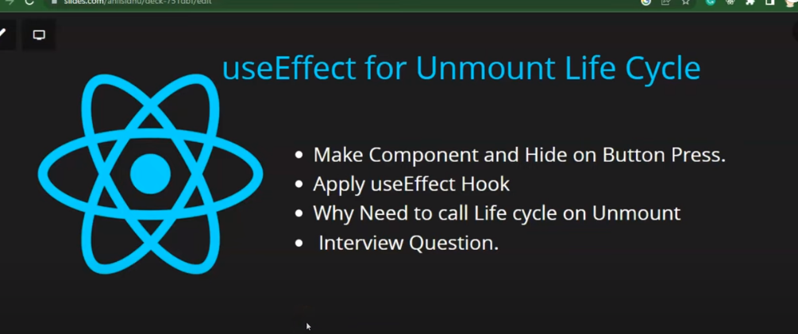

import {React, useState, useEffect} from 'react';

import {

  View,

  Text,

  TextInput,

  TouchableOpacity,

  FlatList,

  Button,

} from 'react-native';

import {StyleSheet} from 'react-native';

*const* App = () *=>* {

*const* [click, setClick] = useState(false);

  return (

    <>

      <*Button*

        title="Press Me"

        onPress={() *=>* {

          setClick(!click);

        }}></*Button*>

      <*View*>

        <*Text*>{click ? <*Student* /> : null}</*Text*>

      </*View*>

    </>

  );

};

*const* Student = () *=>* {

  useEffect(() *=>* {

    return () *=>* {

      console.warn('Component has been unmounted');

    };

  });

  return (

    <>

      <*View*>

        <*Text*>Student</*Text*>

      </*View*>

    </>

  );

};

export default App;

15 .



16 .

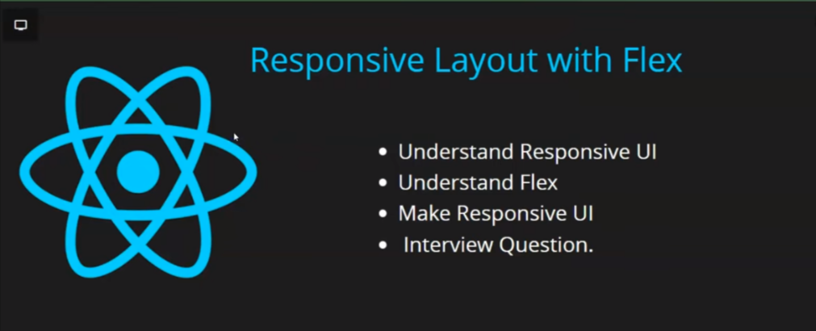

-->usderstanding reactive-native-flex

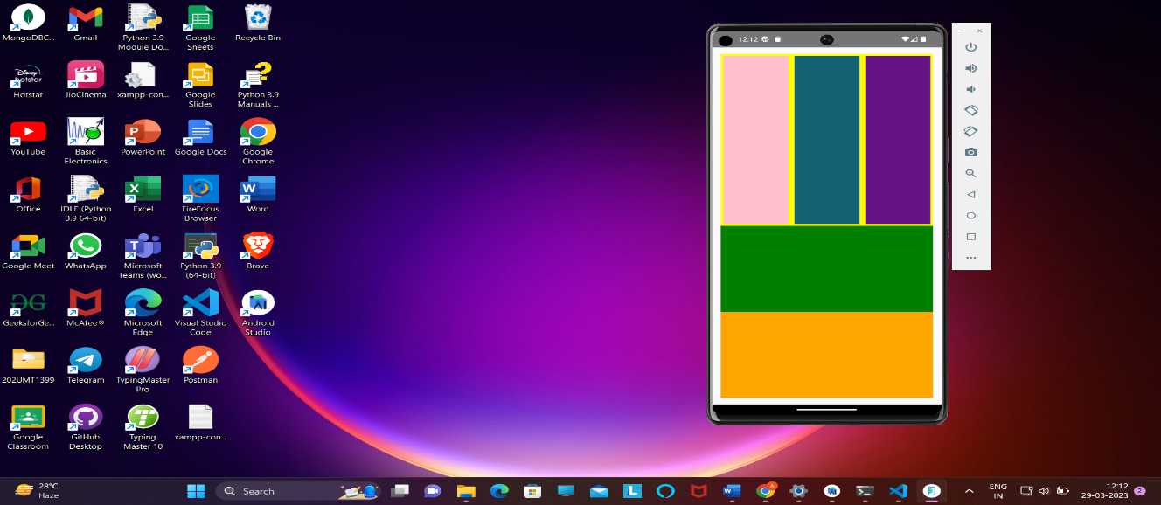

import {React, useState, useEffect} from 'react';

import {View, Text} from 'react-native';

import {StyleSheet} from 'react-native';

*const* App = () *=>* {

  return (

    <>

      <*View* style={style.main}>

        <*View* style={style.box1}>

          <*View* style={style.innerbox1}></*View*>

          <*View* style={style.innerbox2}></*View*>

          <*View* style={style.innerbox3}></*View*>

        </*View*>

        <*View* style={style.box2}></*View*>

        <*View* style={style.box3}></*View*>

      </*View*>

    </>

  );

};

*const* style = StyleSheet.create({

  main: {

    flex: 1,

    backgroundColor: 'red',

    margin: 15,

    borderRadius: 10,

  },

  box1: {

    flex: 2,

    backgroundColor: 'yellow',

    flexDirection: 'row',

  },

  box2: {

    flex: 1,

    backgroundColor: 'green',

  },

  box3: {

    flex: 1,

    backgroundColor: 'orange',

  },

  innerbox1: {

    flex: 1,

    backgroundColor: 'pink',

    margin: 5,

  },

  innerbox2: {

    flex: 1,

    backgroundColor: '#126474',

    margin: 5,

  },

  innerbox3: {

    flex: 1,

    backgroundColor: '#651285',

    margin: 5,

  },

});

export default App;

17.

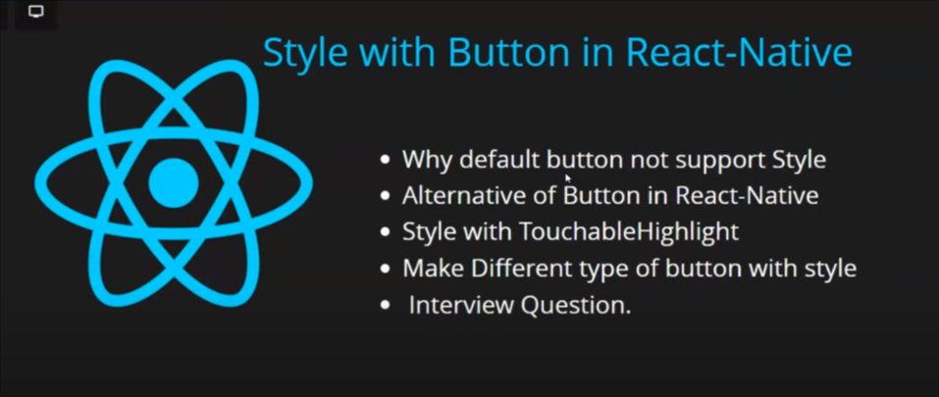

or use TouchableOpacity

18.

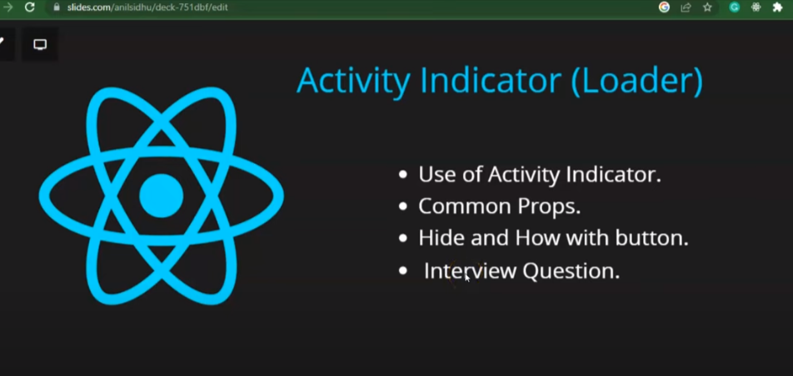

import {ActiveIndicator}

major element :

i)color={}

ii)size={40}

iii)animating={true/false}

import {React, useState} from 'react';

import {

  View,

  Text,

  TouchableOpacity,

  ActivityIndicator,

  TouchableHighlight,

} from 'react-native';

import {StyleSheet} from 'react-native';

*const* App = () *=>* {

*const* [spinner, setSpinner] = useState(false);

  setTimeout(() *=>* {

    setSpinner(false);

  }, 5000);

  return (

    <>

      <*View*>

        <*ActivityIndicator* size={50} color={'green'} animating={spinner} />

        <*TouchableHighlight*

          onPress={() *=>* {

            setSpinner(!spinner);

          }}>

          <*Text* style={style.button}>Submit</*Text*>

        </*TouchableHighlight*>

      </*View*>

    </>

  );

};

*const* style = StyleSheet.create({

  button: {

    paddingHorizontal: 15,

    paddingVertical: 8,

    width: 90,

    backgroundColor: 'green',

    color: 'white',

    alignSelf: 'center',

    marginTop: 10,

  },

});

export default App;

19.

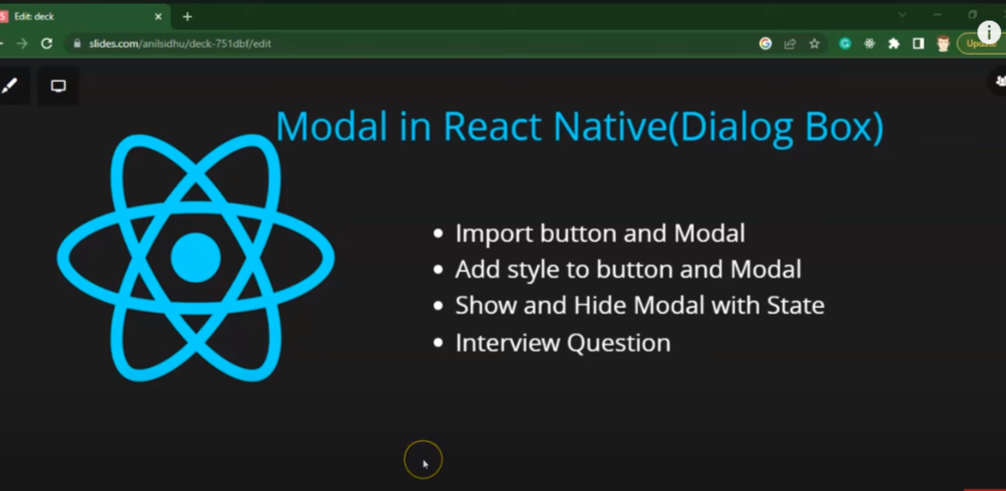

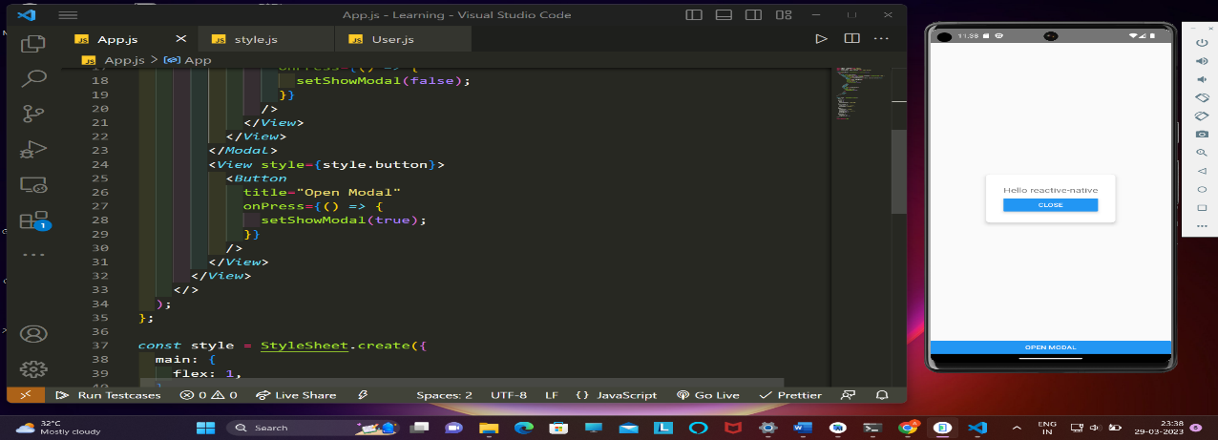

important element:

transparent={true}

ii)visble={true/false},

iii) animationType:’slide/fade/none’

import {React, useState} from 'react';

import {View, Text} from 'react-native';

import {StyleSheet, Modal, Button} from 'react-native';

*const* App = () *=>* {

*const* [showModal, setShowModal] = useState(false);

  return (

    <>

      <*View* style={style.main}>

        <*Modal* transparent={true} visible={showModal} animationType='fade'>

          <*View* style={style.centerViewed}>

            <*View* style={style.modal}>

              <*Text* style={style.modalText}>Hello reactive-native</*Text*>

              <*Button*

                style={style.modalButton}

                title="close"

                onPress={() *=>* {

                  setShowModal(false);

                }}

              />

            </*View*>

          </*View*>

        </*Modal*>

        <*View* style={style.button}>

          <*Button*

            title="Open Modal"

            onPress={() *=>* {

              setShowModal(true);

            }}

          />

        </*View*>

      </*View*>

    </>

  );

};

*const* style = StyleSheet.create({

  main: {

    flex: 1,

  },

  button: {

    flex: 1,

    justifyContent: 'flex-end',

  },

  centerViewed: {

    flex: 1,

    justifyContent: 'center',

    alignItems: 'center',

  },

  modal: {

    shadowColor: 'black',

    elevation: 5,

    backgroundColor: 'white',

    padding: 30,

    borderRadius: 8,

  },

  modalText: {

    fontSize: 18,

    marginBottom: 10,

  },

});

export default App;

20.

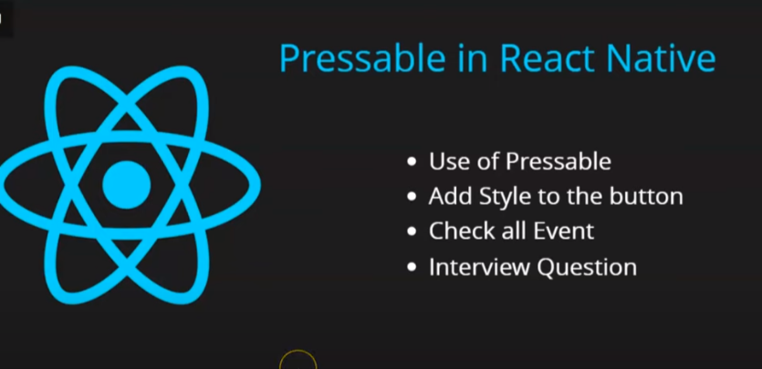

pressable element :

i)onpress()

ii)onLongPress()

iii)onPressIn()

iv)onpressOut()

import {React, useState} from 'react';

import {View, Text} from 'react-native';

import {StyleSheet, Pressable, Button} from 'react-native';

*const* App = () *=>* {

  return (

    <>

      <*Pressable*

        style={style.main}

        onLongPress={() *=>* {

          console.warn('long press');

        }}>

        <*Text* style={style.pressable}>pressMe</*Text*>

      </*Pressable*>

    </>

  );

};

*const* style = StyleSheet.create({

  main: {

    flex: 1,

    justifyContent: 'center',

  },

  pressable: {

    borderWidth: 2,

    alignSelf: 'center',

    paddingHorizontal: 10,

    paddingVertical: 8,

    backgroundColor: 'green',

    color: 'white',

    fontSize: 20,

  },

});

export default App;

21.

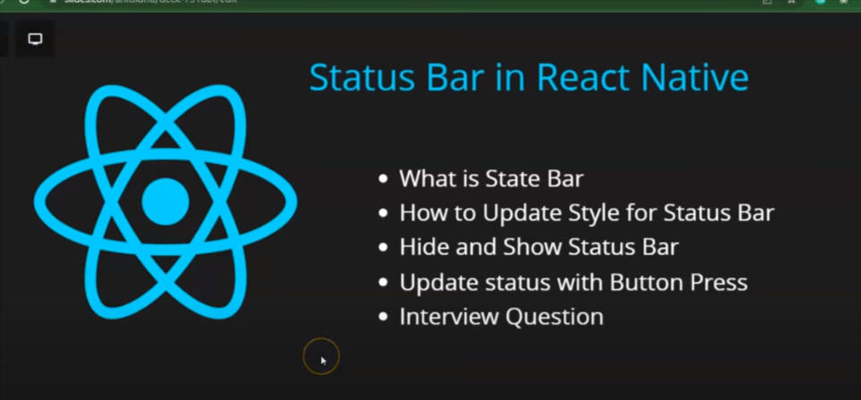

element:

i)BackgroundColor={}

ii)barStyle={}

iii)hidden={true/false}

22.

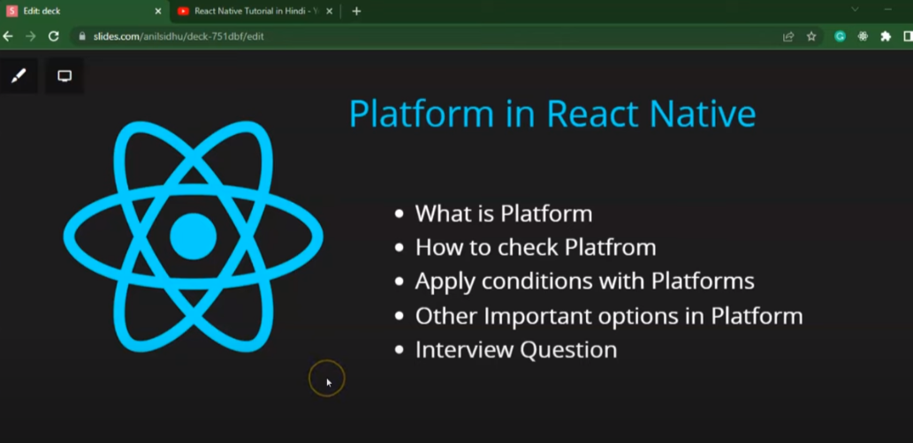

plateform : through this we can check the operation system on which we are working

element :

i)palterform.Os

ii)Plateform.isTv

iii)Plateform.isIpad

23.

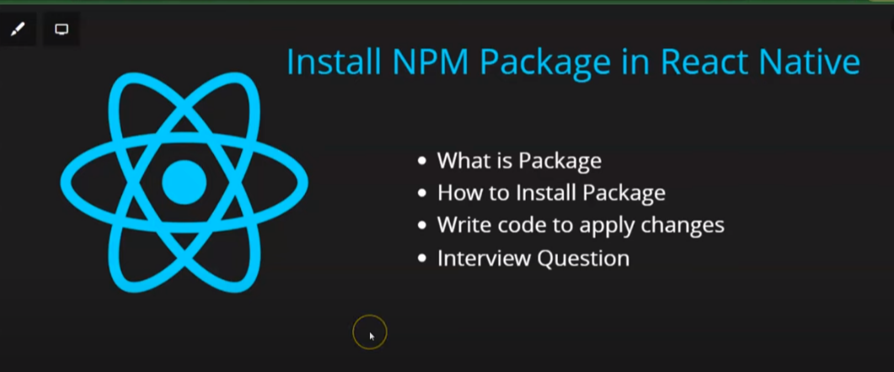

react-native-webview package

->through this we can put and things of other websiter

24 .

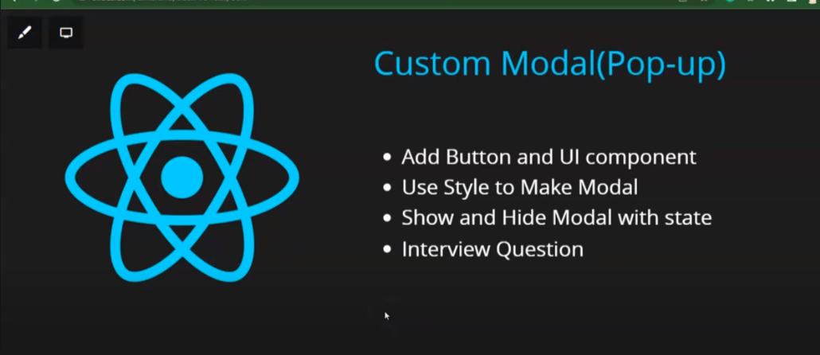

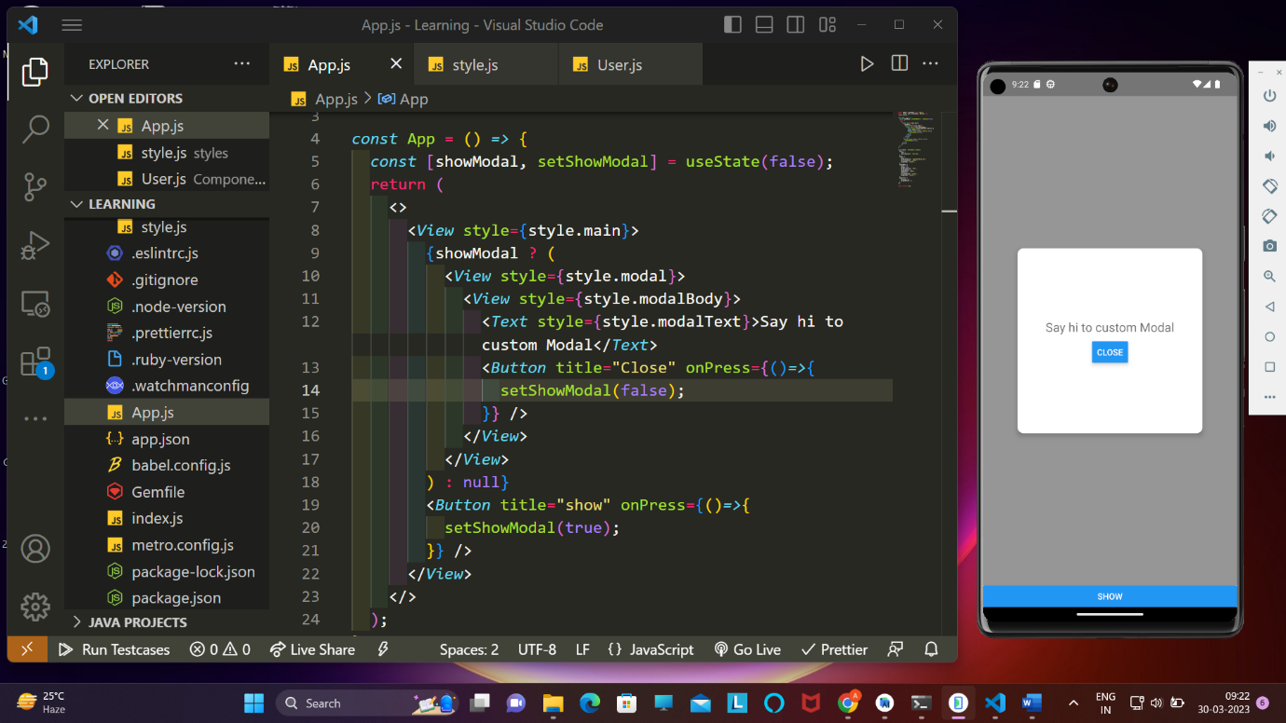

import {React, useState} from 'react';

import {View, Text, StyleSheet, Button} from 'react-native';

*const* App = () *=>* {

*const* [showModal, setShowModal] = useState(false);

  return (

    <>

      <*View* style={style.main}>

        {showModal ? (

          <*View* style={style.modal}>

            <*View* style={style.modalBody}>

              <*Text* style={style.modalText}>Say hi to custom Modal</*Text*>

              <*Button* title="Close" onPress={()*=>*{

                setShowModal(false);

              }} />

            </*View*>

          </*View*>

        ) : null}

        <*Button* title="show" onPress={()*=>*{

          setShowModal(true);

        }} />

      </*View*>

    </>

  );

};

*const* style = StyleSheet.create({

  main: {

    flex: 1,

    justifyContent: 'flex-end',

  },

  modal: {

    flex: 1,

    backgroundColor: 'rgba(50,50,50,0.5)',

    justifyContent: 'center',

    alignItems: 'center',

  },

  modalBody: {

    width: 300,

    height: 300,

    backgroundColor: '#fff',

    borderRadius: 10,

    shadowColor: 'black',

    elevation: 5,

    justifyContent: 'center',

    alignItems: 'center',

  },

  modalText: {

    fontSize: 20,

    marginBottom: 10,

  },

});

export default App;

25 .

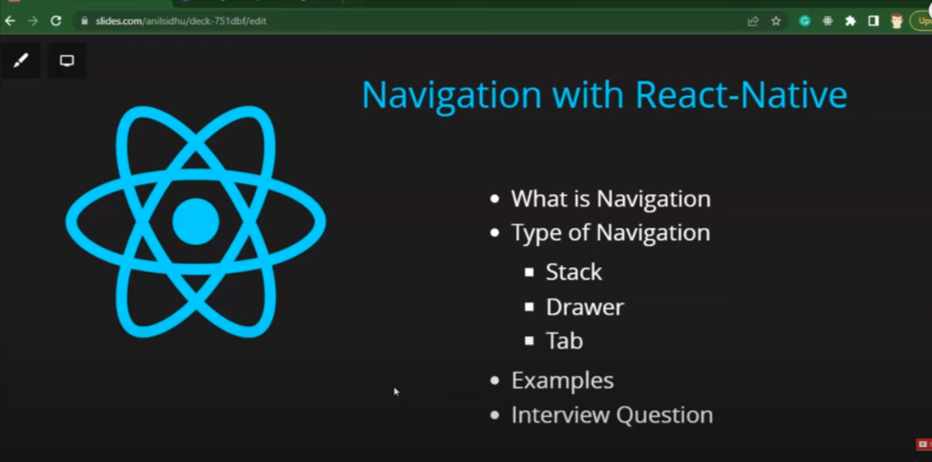

i)stack navigation

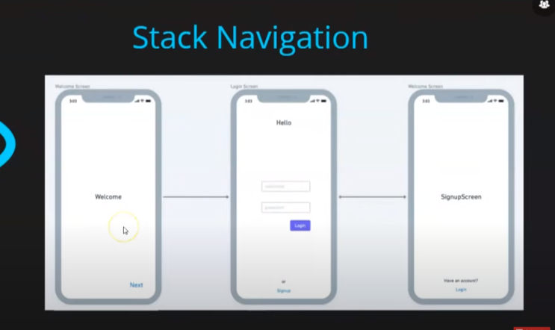

ii)Drawer Navigation

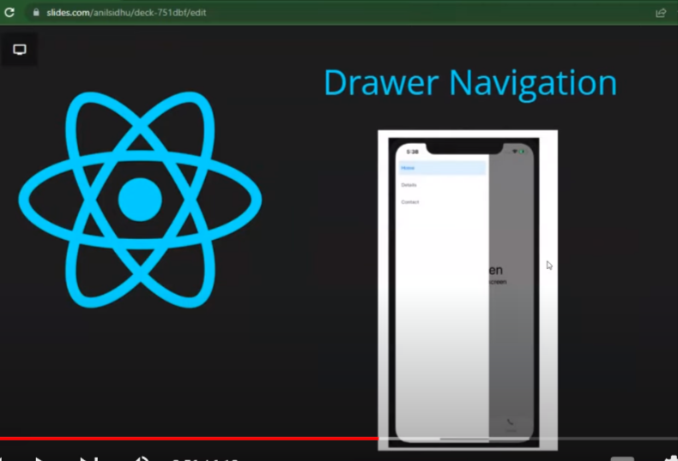

iii) Tab Navigation

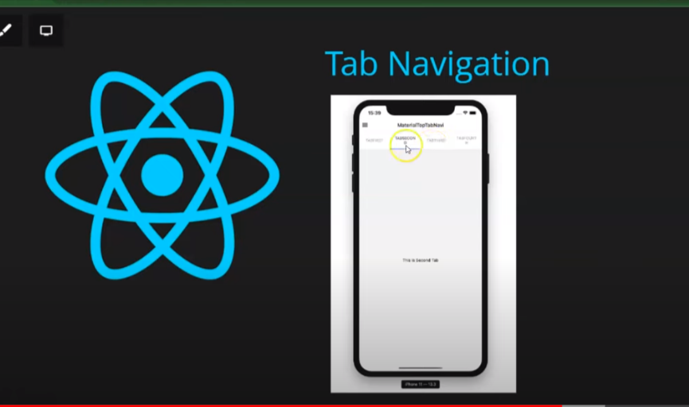

1-> stack navigation

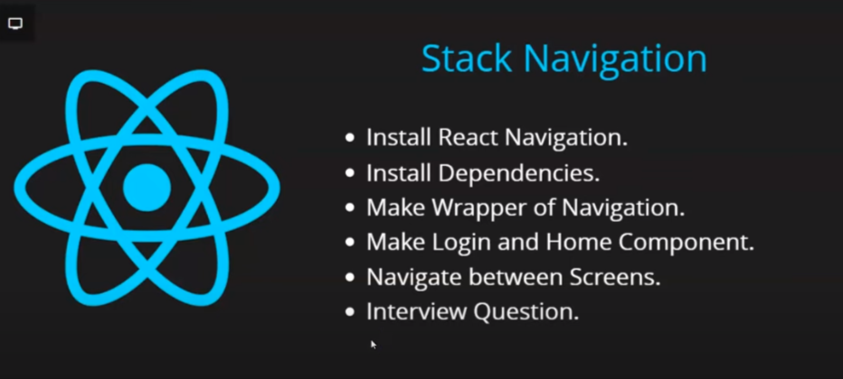

to insall navigation :

<https://reactnavigation.org/docs/getting-started/>

import React from 'react';

import {View, Text, StyleSheet, Button} from 'react-native';

import {NavigationContainer} from '@react-navigation/native';

import {createNativeStackNavigator} from '@react-navigation/native-stack';

*const* stack = createNativeStackNavigator();

*function* App(): JSX.Element {

  return (

    <>

      <*NavigationContainer*>

        <*stack.Navigator*>

          <*stack.Screen* name="Login" component={Login} />

          <*stack.Screen* name="Home" component={Home} />

        </*stack.Navigator*>

      </*NavigationContainer*>

    </>

  );

}

*const* Home = *props* *=>* {

  return (

    <>

      <*View* style={style.Home}>

        <*Text* style={style.HomeText}>Home Screen </*Text*>

      </*View*>

    </>

  );

};

*const* Login = *props* *=>* {

  return (

    <>

      <*View* style={style.Home}>

        <*Text* style={style.HomeText}>Login Screen</*Text*>

        <*Button*

          title="Go TO HOMEPAGE"

          onPress={() *=>* {

*props*.navigation.navigate('Home');

          }}

        />

      </*View*>

    </>

  );

};

*const* style = StyleSheet.create({

  Home: {

    flex: 1,

    backgroundColor: 'grey',

    justifyContent: 'center',

    alignItems: 'center',

  },

  HomeText: {

    fontSize: 30,

    color: 'white',

  },

});

export default App;

ii)

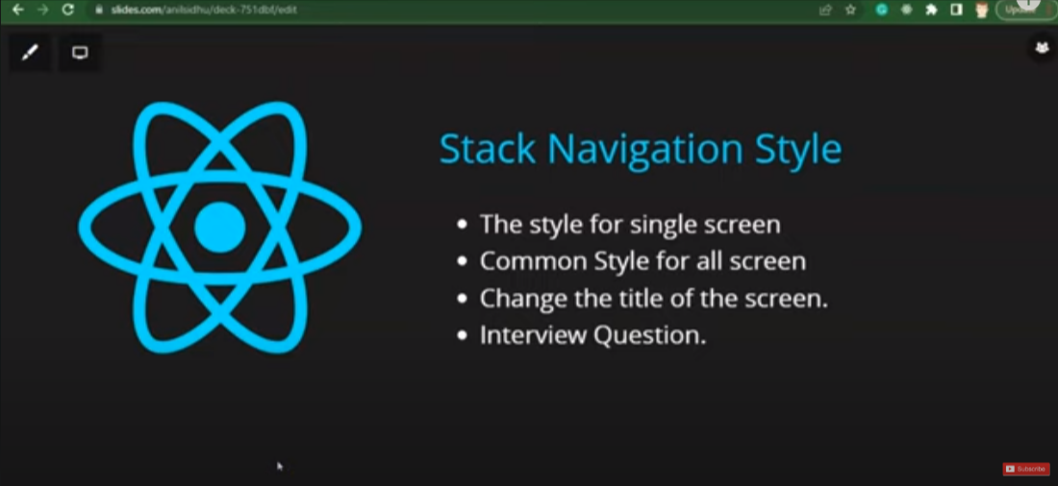

a)styling the hadder of a paticular screen

<*stack.Screen*

            name="Login"

            component={Login}

            options={{

              title: 'login Page',

              headerStyle: {

                backgroundColor: 'orange',

              },

              headerTitleStyle: {

                color: 'white',

                fontSize: 19,

              },

            }}

          />

          <*stack.Screen* name="Home" component={Home} />

b)styling with the common style

<*stack.Navigator*

          screenOptions={{

            headerStyle: {

              backgroundColor: 'orange',

            },

            headerTitleStyle: {

              color: 'white',

              fontSize: 19,

            },

          }}>

          <*stack.Screen* name="Login" component={Login} />

          <*stack.Screen* name="Home" component={Home} />

        </*stack.Navigator*>

iii)



by using :

a)for left portion :

headerTitle:()=>{},

b)for Right portion :

headerRight():()->{};

 options={{

              headerTitle: () *=>* <*Button* title="Left" />,

              headerRight: () *=>* <*Button* title="Right" />,

            }

iv)

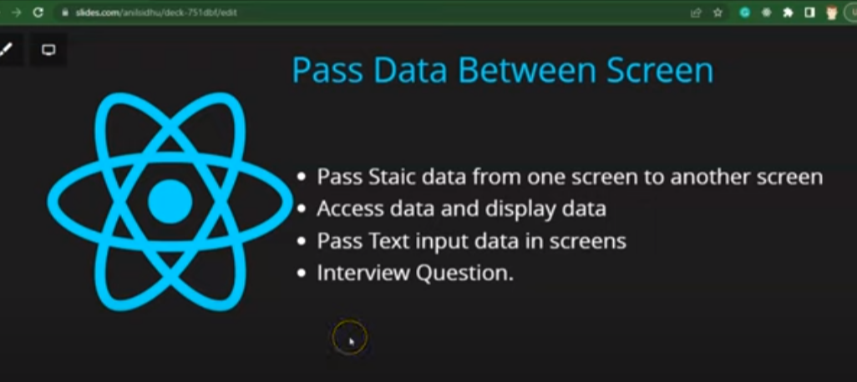

a)passing data

by passing a object as second arugment for props.navigation.navigate(“Home”,{});

<*Button*

          title="Go TO HOMEPAGE"

          onPress={() *=>* {

*props*.navigation.navigate('Home', {name: 'Ajaj', id: '2020UMT'});

          }}

        />

b)getting data

by useing props:

props.route.params

*const* {name, id} = *props*.route.params;

2.



to install packages

<https://reactnavigation.org/docs/tab-based-navigation>

import React from 'react';

import {View, Text, Button} from 'react-native';

import {NavigationContainer} from '@react-navigation/native';

import {createBottomTabNavigator} from '@react-navigation/bottom-tabs';

*const* Tab = createBottomTabNavigator();

*function* App() {

  return (

    <>

      <*NavigationContainer*>

        <*Tab.Navigator*>

          <*Tab.Screen* name="Login" component={Login} />

          <*Tab.Screen* name="SignU" component={Sign} />

        </*Tab.Navigator*>

      </*NavigationContainer*>

    </>

  );

}

*function* Login() {

  return (

    <*View*>

      <*Text*>Login</*Text*>

    </*View*>

  );

}

*function* Sign() {

  return (

    <>

      <*View*>

        <*Text*>SingnUp</*Text*>

      </*View*>

    </>

  );

}

export default App;

ii)

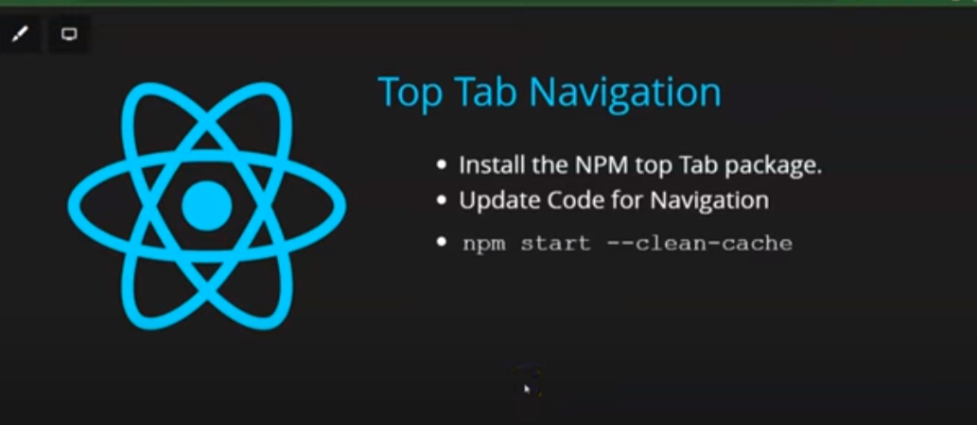

install pakages

<https://reactnavigation.org/docs/material-top-tab-navigator>

import React from 'react';

import {View, Text, Button} from 'react-native';

import {NavigationContainer} from '@react-navigation/native';

import {createMaterialTopTabNavigator} from '@react-navigation/material-top-tabs';

*const* Tab = createMaterialTopTabNavigator();

*function* App() {

  return (

    <>

      <*NavigationContainer*>

        <*Tab.Navigator*>

          <*Tab.Screen* name="Login" component={Login} />

          <*Tab.Screen* name="SignU" component={Sign} />

        </*Tab.Navigator*>

      </*NavigationContainer*>

    </>

  );

}

*function* Login() {

  return (

    <*View*>

      <*Text*>Login</*Text*>

    </*View*>

  );

}

*function* Sign() {

  return (

    <>

      <*View*>

        <*Text*>SingnUp</*Text*>

      </*View*>

    </>

  );

}

export default App

3. Drawer Navigantion

installiation :

<https://reactnavigation.org/docs/drawer-navigator#installation>

26.



import React, {useEffect, useState} from 'react';

import {View, Text, Button, StyleSheet} from 'react-native';

*function* App() {

*const* [detail, setDetail] = useState(null);

*const* getData = async () *=>* {

*const* resp = await fetch('https://jsonplaceholder.typicode.com/posts/2');

*const* data = await resp.json();

    setDetail(data);

  };

  useEffect(() *=>* {

    getData();

  }, []);

  return (

    <>

      {detail ? (

        <*View* style={style.box}>

          <*Text*>id : {detail.id}</*Text*>

          <*Text*>userId : {detail.userId}</*Text*>

          <*Text*>Title : {detail.title}</*Text*>

          <*Text*>Body : {detail.body}</*Text*>

        </*View*>

      ) : null}

    </>

  );

}

*const* style = StyleSheet.create({

  box: {

    padding: 20,

    margin: 30,

    backgroundColor: 'yellow',

  },

});

export default App;

ii)

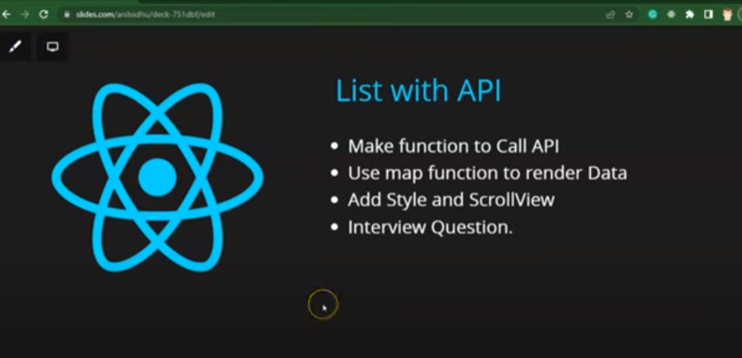

import React, {useEffect, useState} from 'react';

import {View, Text, Button, StyleSheet,ScrollView} from 'react-native';

*function* App() {

*const* [detail, setDetail] = useState(null);

*const* getData = async () *=>* {

*const* resp = await fetch('https://jsonplaceholder.typicode.com/posts/');

*const* data = await resp.json();

    setDetail(data);

  };

  useEffect(() *=>* {

    getData();

  }, []);

  return (

    <*ScrollView*>

      {detail ? (

        detail.map((*item*)*=>*

        <*View* style={style.box}>

          <*Text*>id : {*item*.id}</*Text*>

          <*Text*>userId : {*item*.userId}</*Text*>

          <*Text*>Title : {*item*.title}</*Text*>

          <*Text*>Body : {*item*.body}</*Text*>

        </*View*>)

      ) : null}

    </*ScrollView*>

  );

}

*const* style = StyleSheet.create({

  box: {

    padding: 20,

    margin: 30,

    backgroundColor: 'yellow',

  },

});

export default App;

ii)



import React, {useEffect, useState} from 'react';

import {

  View,

  Text,

  Button,

  StyleSheet,

  ScrollView,

  FlatList,

  VirtualizedList,

} from 'react-native';

*function* App() {

*const* [detail, setDetail] = useState(null);

*const* getData = async () *=>* {

*const* resp = await fetch('https://jsonplaceholder.typicode.com/posts/');

*const* data = await resp.json();

    setDetail(data);

  };

  useEffect(() *=>* {

    getData();

  }, []);

  return (

    <*View*>

      {detail ? (

        <*FlatList*

          data={detail}

          renderItem={({*item*}) *=>* (

            <*View* style={style.box}>

              <*Text*>Id: {*item*.id}</*Text*>

              <*Text*>userId: {*item*.userId}</*Text*>

              <*Text*>Title: {*item*.title}</*Text*>

              <*Text*>Body: {*item*.body}</*Text*>

            </*View*>

          )}

          keyExtractor={*item* *=>* *item*.id}

        />

      ) : null}

    </*View*>

  );

}

*const* style = StyleSheet.create({

  box: {

    padding: 20,

    margin: 30,

    backgroundColor: 'yellow',

  },

});

export default App;

27.



virtulized list :

<*VirtualizedList*

              data={tasks}

              initialNumToRender={4}

              renderItem={({ *item* }) *=>* <*Task* data={*item*} />}

              keyExtractor={(*item*) *=>* *item*._id}

              getItemCount={(*tasks*) *=>* *tasks*.length}

              getItem={(*tasks*, *index*) *=>* {

                return *tasks*[*index*];

              }}

            />

diffrence between flatList and virtualFlatList:

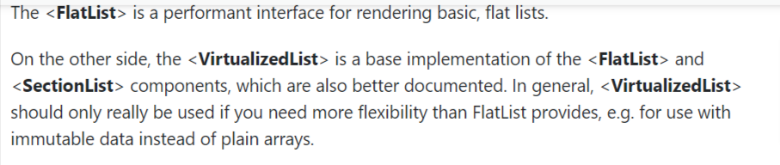

==>camera

pakages :

i)expo camera

<https://docs.expo.dev/versions/latest/sdk/camera/>

ii)expo image Picker

<https://docs.expo.dev/versions/latest/sdk/imagepicker/>

* redux instilation

1. npm install react-redux
2. npm install @reduxjs/toolkit

expo font family :

project food app

* creating a function to give width and height

Way of using image :

<*Image* style={style.image} source={Images[*image*]} resizeMode="contain" />